BMKT001

Marketing Foundations

Assignment title: Marketing Plan for Google pen
Student number | Student name | Student signature (please read the Declaration below and sign)
To be completed by the Group upon submission:
Tutors name: …………………………………………………………………………………………….
Assignment Due Date: ……………………………………………………………………………….
Word count (excluding reference list): ……………………………………………………….
Turnitin percentage: ………………………………………………………............................

TABLE OF CONTENTS
1. Executive Summary 4
2. Introduction 5
3. SWOT Analysis 7
4. Market research questionnaire findings 9
5. Target Market 13
6. Objectives 15
6.1 Financial Objectives 15
6.2 Marketing objectives 15
7. Key consideration & Product Strategy 16
7.1 Product Class 16
7.2 Product Life Cycle 16
7.3 Product Line 16
7.4 Each level of the product 16
7.4.1 Core product 16
7.4.2 Expected product 17
7.4.3 Augmented product 17
7.4.4 Potential product 17
8. Price Strategy 18
8.1 Price Objectives 18
8.1.1 Profit objective 18
8.1.2 Market share 18
8.2 Price method 18
8.2.1 Mark-up Pricing 19
8.2.2 Break-even analysis 19
8.2.3 Marginal analysis 19
8.3 Price Management 19
8.3.1 Psychology of Price 19
8.3.2 Pricing throughout the Product Life Cycle 20
8.3.3 Setting and Managing Final Price 20
9. Promotion strategy 21
9.1 Awareness creation 21
9.2 Demand Stimulation 21
9.2.1 Pull strategy 21
9.2.2 Push strategy 22
9.3 Advertising 22
9.4 Sales promotion 24
9.5 Additional Forms of Promotion 24
25
10. Place strategy 26
10.1 Distribution Channel 26
10.2 Physical Distribution 27
10.2.1 Warehousing 27
10.2.2 Transportation 28
10.2.3 Technology 28
10.3 Intermediaries 28
10.3.1 Retailer 28
10.3.2 Wholesaler 29
11. Conclusion 30
12. Reference list 31

Executive Summary
This report introduces Google’s most innovative product Google Pen. Its sole purposes are to enhance the feature and bring an evolution on recoding. The target customers for Google Pen are Google lover, people in the academic areas and technology savvy. They all have unique motives to purchase the Google Pen, which is based on Geographic segmentation, behavioural segmentation, psychographic segmentation and demographic segmentation. As one of the most influential and financial stable company in the world, Google will provide a significantly effective and appropriate resource both financial and technology on the Google Pen project. Google aims not only to use the Google Pen as a pathway to earn more profit but also hoping the usage of the product can change the world of our daily life. However, one down fall is that Google has a lack of experience selling practical good in market, which they will have to adjust it through the knowledge and years of experience they have for selling digitalise product.
Furthermore, the report will demonstrate the essential factor in order to guide the success of Google Pen through clearly lay out the goals of the product, how to achieve those goals and where the product stand. The ultimate objectives of the Google Pen is success in financially and marketing portions. This will be done be a clear layout of strength, weakness, threats and opportunities for both the product and company. Once that been clarified, an appropriate strategies including, product, price, promotions and place will apply to ensure the product is on the right path.
By following the detailed information provided by the report, it will sure guarantee the success of Google Pen.

Introduction
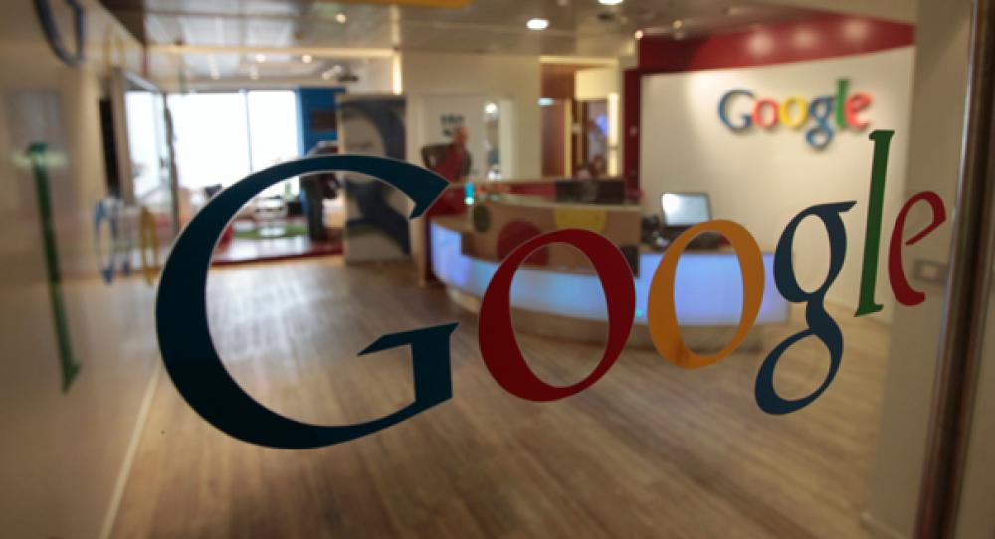
Google is an America multinational technology corporate, it focus on the business industries of internet search engine, cloud computing, and advertisement technology (Reuter 2014). It also develops a variety of goods and services that base on internet. Its main income profits come from advertisement companies such as AdWords.

History of the company
Google was founded by Larry Page and Sergey Brin during their time they were in University of Stanford, as they now have been known as ‘Google Guys’. In 4th of September 1998, Google became a private business structure, design and manage an internet search engine however the Google website didn’t start until late 1999. The business motto for Google is gathering up information around the world so that everyone can use it and benefit from it. In addition Google also has a really strong ethic value as this is conveys through their mission statement ‘don’t be evil.’ Google always believed that it’s possible to make money without being evil (Google 2014). As now days Google crowned the world biggest search engine due to the fact of the countless users around the world.
As mention above, Google’s goods and services are heavily and mainly base on internet. Which mean they come in a digital format. For examples, these include Google search engine, G-mail, the rights to put an advertisement in the search result, Google chrome, android, Google translate and Google plus etc. These are all products that is use and sell online in digital format. It is rare to see a practical good outside real life retail market, the closest thing will be the Google Pad and Google Glass which the Google Glass is still in process of developing.

Although Google still maintain a very high level of profit making, the business has been threaten by its rival Apple Inc. and other companies such as Yahoo and Microsoft, as Google has a very lack of practical goods to sell in the market. Like the mockery about Google, ‘You use everything from Google but you never buy anything from Google.’ As for now, Google still maintain a very large portion of market share in the technology business but taking a look at the Nokia fall down from phone industry due to impact from Apple, it is clever and safe for Google to release a practical product to the market that can grab the world attention and makes it becomes part of people’s daily life.
In order to respond to the strategy plan of releasing a product that has the potential to become a daily item, Google’s most secreted develop team ‘Google X’ has come up with the idea ‘Google Pen’. As the team believe recording and the item pen is an essential for everyone’s daily life even with the rise of technology. The feature and benefit of the ‘Google Pen’ is believe to be strong enough to combats the iPhone by Apple and Microsoft’s document software. Try to focus on the future and think about what kind of future that is actually going to be (Larry Page, 2014)
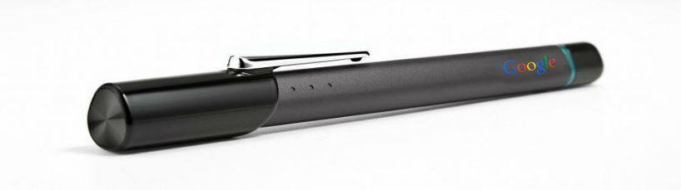
Google pen with HD camera:

SWOT Analysis
SWOT Analysis is an evaluation of the internal strengths and weakness as well as external opportunities and threats of the company and products, which is helpful for understanding advantages and disadvantages in both internal organization and external environment (Schermerhorn et al, 2011).
STRENGTHS | - Google is a well-known company and has a good brand image in the world. Google is a wealthy company in the world with revenue of $59,825 million in the fiscal financial year 2013, so it owns financial advantage to support implementation of plan (Market Line, 2014).  - The company has skilful employees and professional team to support process of research and manufacture Google Pen (ProQuest, 2014). Therefore, Google Pen is well-developed and satisfies customers with its small and portable characteristic.  - The new Google Pen will be the first multi-functional pen which gathers functions of taking picture, record video and transforming writing information into e-document.
WEAKNESSES | - More than 90% of Google’s revenue comes from online advertising Google(Inc. SWOT Analysis, 2014) Actually, relying on one source of income will increase the risk of income growth in long run (ProQuest, 2014).  - Google products have a limited customer base because there are no profitable products in Google before 2012(Jurevicius, 2013). As the result, we may see that revenue in Google Pen grow slowly in short term.  - The high price Google pen can force consumers choosing other substitute products with the similar function. Therefore, consumers have to consider carefully before purchasing.  - Google pen require Bluetooth or Wifi connection to smart phone or laptops. Once the pen out of power, it needs to be charged/replace batteries.
OPPORTUNITIES | - Google Company reported that its investors enjoyed profit margin in 2013 and those investor are willing to keep investing in Google Company(Google Inc. Form 10-K, 2014) There is an evidence that Google enjoyed a 65.2% share of web search volume worldwide as December, 2012(Internet Live Stats. 2013)  - Google searching engine has a huge customer’s base and it can utilize its website to advertising Google Pens  - Relative opportunity is the growing numbers of technological products users in the world. They are potential consumers willing to buy Google Pen  - There is a potential chance to make Google Pen become a trend in the future.
THREATS | - When talking about threats, competitors would be the first threat to Google Company. Other big competitors like HTC, Samsung, and Huawei would perform similar products later and cut out the market share.  - The following threat is a cause of the negative effects from economic slowdown. Google Pen is not an essential good so that people can choose other cheaper products when the pen is over budget.  - The next threat is potential damage of Google reputation. The technology industry suffers daily security attacks to its systems (Jurevicius, 2013). The leaking of Google users’ data could be devastating to the reputation of the organization.  - Additionally, Google Pen may be unwelcome in some place because of privacy issues.

Market research questionnaire findings
In order to understand our market as well as to have the right direction in strategy for Google pen, we had taken a survey on 30 people. The survey included 8 questions and 4 of them illustrated important key data to our marketing plan. This marketing survey can be considered to be exploratory research which refers to the term of taking actions by doing research on loosely defined problems (Shields et al., 2013). Since it is a quantitative research, all information is shown by graphs showing the numeral data.
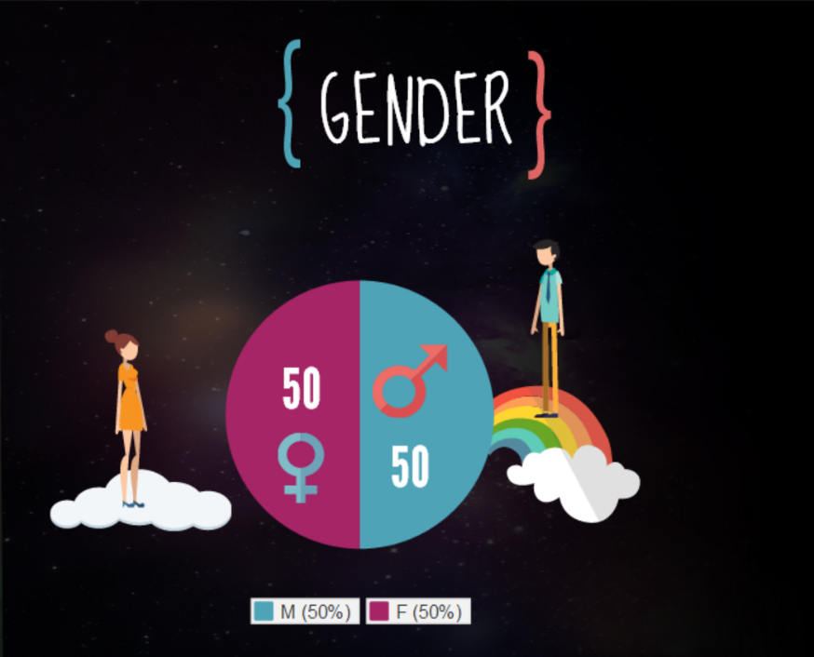

First of all, the questionnaire was taken on 15 female and 15 male which showed an equal result for both genders. It helps our company to understand clearly the demand for the product by both men and women to have more precise decision for our target market.
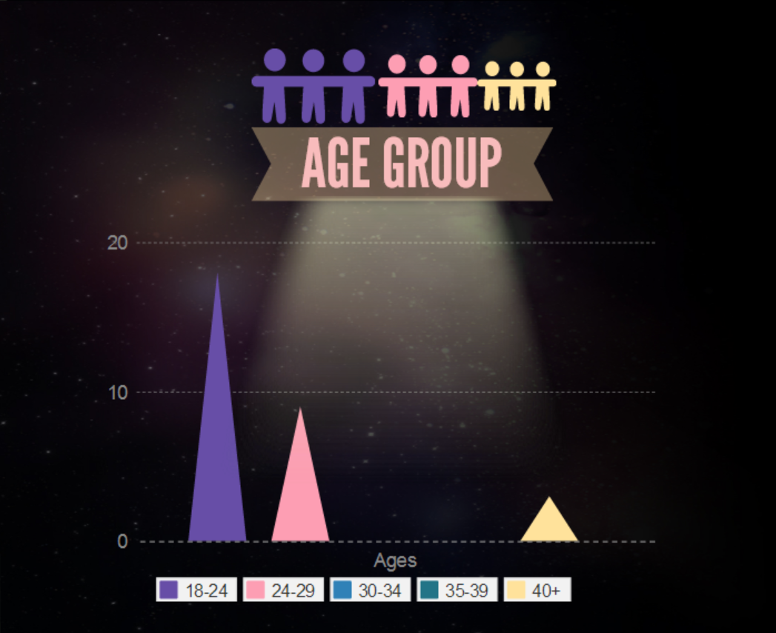

Secondly, the majority of respondents were people who fell between 18 and 24, following by the group of 24 to 29 years old. None of them were from 30 to 39 and only 3 of respondents were over 40.
The result of age group findings showed clearly that people who are young catch up the most with new technology devices. Therefore, one of the target market of Google pen will be young people such as university students, the young who are curious about brand new things, etc.

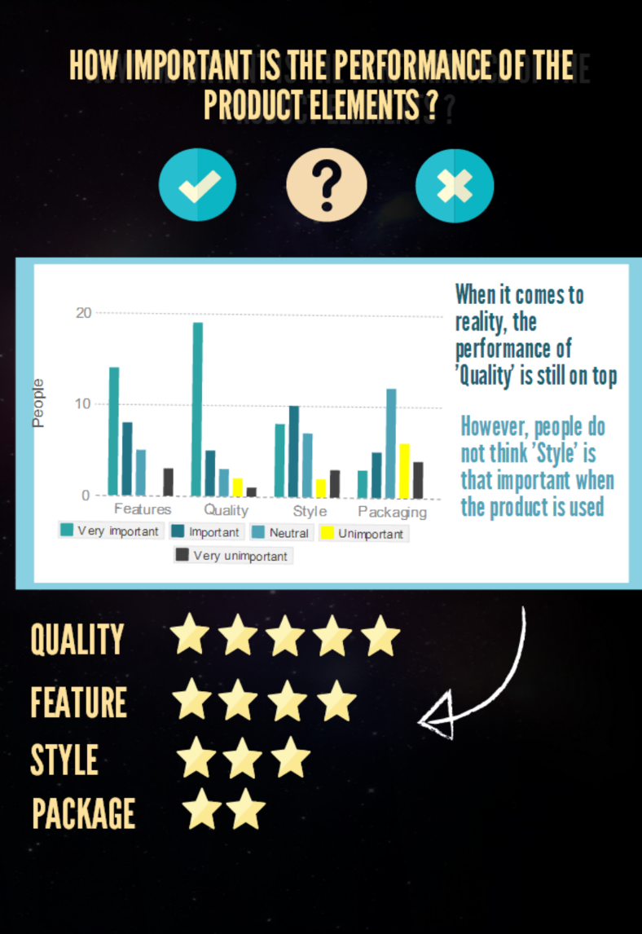

The interviewees were asked about how important the performance of product elements was to them. The data collected from respondents showed that amongst Features, Quality, Style and Packaging, Quality is the most important element to respondents. Features are the second essential factor of a product, followed by Style. However, Package does not matter to most of interviewee. Therefore, Google will focus on the quality and feature of Google pen. We try to produce the product with the best materials and devices but still keep the price reasonable by lowering the package cost and make it as simple and elegant as possible.
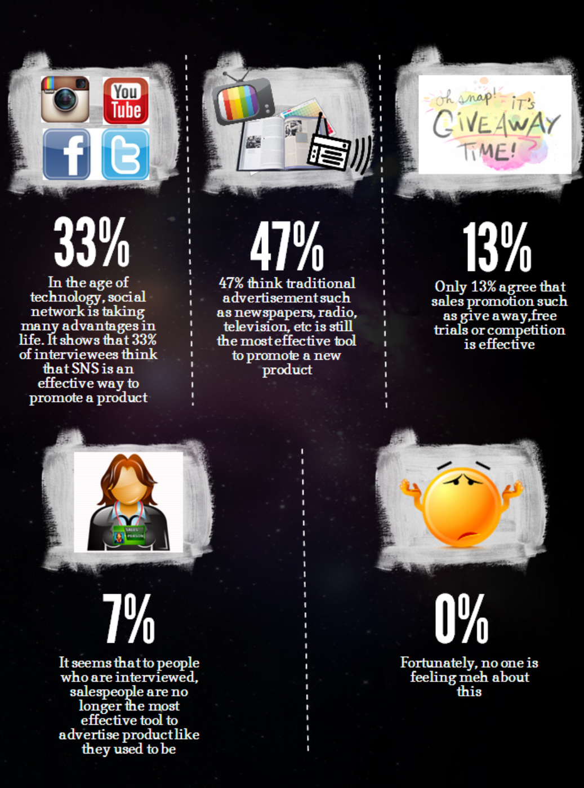

According to the questionnaires, it shows that nearly 50% of respondents pay attention to a new production by traditional advertisements such as newspaper, radio, television. Moreover, 33% of them like the online promotion via Internet. It has impacts on the company’s promotion strategy as we will choose to advertise Google pen via traditional advertisement as well as our official website and Facebook.

Target Market
Target market is a set of specific group of buyers at which a business aims its goods and services. These groups of consumers have common or unique wants, needs and demands (Elliot 2014). This target group is based on people who are most likely to buy from us.
Our new product’s target market is Australian people. According to Australian Bureau of Statistics (2013), current population (25th October 2014) in Australia is above 23,658,468 and it is keep increasing of one person every 1 minute and 17 seconds. Estimated total population in Australia in 2030 is 30 million, thus it is increasing market that provides more opportunities over time.
The Google Pen’s target market has three segments, which are Google lovers, Educational Users and Technological savvy. These segments are based on market segmentations that divided into four different sectors, which is demographic segmentation, geographic segmentation, psychographic segmentation and behavioural segmentation.

Google lovers

Google can expect some sales benefit from its brand value. Google has 2nd highest brand value in the world á well as a title of biggest search engine in the world. Many people support Google because it provides several of free services such as Google maps, Google drive, Gmail, Google wallet, books and a lot of others. This is why so many people support Google; they are having numerous advantages from Google without cost. As Google provides perfect service to Google users, they have trust in their brand name and consumers will believe that Google product is perfect and high quality.
Educational user

Teachers and students are one group of Google Pen’s target market. Since Google pen has scanner feature teachers and students does not require scanner to scan their documents. Moreover, student will not need to carry heavy note book anymore. Only thing they need is some sheets of papers and after finish their writing they can throw paper away because all the things they have wrote will be in their smart phone or stored in pen. Google Pen helps them to keep their information safely and makes easier to enjoy their unique experience with communities via sharing their files with other people.

Technology savvy

Google’s target consumers are people that have broad knowledge on modern technology, which is known as technology savvy. Technology savvy is mostly young aged to middle aged people who loves to spend their free time to search and try new electronic good (Cambridge 2014). Since they are interested in new technological features than others, Google pen is nice enough to satisfy their interest. Also they are interested and experienced in new technology and love to discover new technological features, they will not have any difficulties of using new Google pen. We are making experience even more exciting with software and application, bringing the unique experience to the Google Pen.

Objectives

Financial Objectives
According to IBIS World (2014), the total revenue of Google Inc. is $954.5 million in 2013-14, also the annual change of revenue about 27.2%. Moreover, the Google Inc. only has a limited market share on technology market in Australia, less than 30% of the revenue with the four major players (Flores, 2014). However, the entry of this industry is low and steady (Flores, 2014), also the Google pen is the new product of the market. That means it will have some benefits if it enters the market. It is predicted that the Google pen will increase the almost 5% to 10% of market share in year. Furthermore, Google pen may increase the revenue of 3% after the first quarter. Finally, the Google Inc. decides to earn rapid profit in the first two year to return as soon as possible the producing cost.

Marketing objectives
The market object is to let the Google Pen become the trend on the world. It results in the ability to increase the volume of the brand and goodwill for Google. Besides, the Google pen is a new style product that changes the human life. This can have benefit on helping more people keep attention to Google Inc. Last but not least, Google pen will provide more function to attract more customers than increase the sale and market share in the future.

Key consideration & Product Strategy

Product Class
Google Inc. is a reputed company with 16 years of establishment and considered to be one of big global technology company (Reuter 2014). Therefore, it is good and easy for Google Pen to access the electronic devices market as Google Inc. is popular for its aspect. Google Pen is regarded as speciality product because people will not buy it often and the purchase bases on demand of customer as the price is high due to its functions.

Product Life Cycle
Product life cycle includes five stages which are new product development, introduction, growth, maturity and decline (Elliott et al, 2014, Chp 7, Slide 20). Google Pen in the product life cycle is at the stage of introduction, because our new features in our product are the first appearance in the market.

Product Line
Product line refers to a set of product having relative attributes such as end use, target market, technology and raw material (Elliott et al, 2012, Chp 7, Slide 11). Google Pen will be considered as a new product line in Google Company, because Google Pen is a new product unrelated to existing product line in Google. Google Pen can be separated into individual products because of the release of two different types of Google Pen.

Each level of the product

Core product
Core product is the product can satisfy customers’ need with its fundamental benefits (Elliott et al.2014, Chp 7, Slides 5). The basic reason for people to purchase Google Pen is its unique features that Google Pen can transfer writing stuff from the paper into e-document. Google Pen is the first to be introduced to the market, which can bring convenience into information gathering and save time.

Expected product
The expected product is used to form the core product with delivering actual attributes (Elliott et al.2014, Chp7, Slides 6). Branding, features, style, packaging, quality standards are essential features that marketers try to distinguish their offerings. In the first introducing stage, we provide two types of pen to satisfy customers with different needs. In both products, we will provide finest materials in manufacturing pens process and design in a modern look as well as package in a case with a real pen picture on the surface making it visually. As far as the brand is concerned, smart pen is belonged to ‘Google’ and there is a logo of Google pen under the brand name. There are two types of Google Pen in regarding to the feature. One is the basic pen using as a tool transferring writing stuffs into e-document, another is updated product with additional HD camera using to record and take pictures.

Augmented product
The augmented product refers to term which customers buy actual product or expected product, customers obtain additional sum of all kinds of interests, including product manuals, warranties, installation, maintenance, delivery, technical training, etc. (Elliott et al.2014, Chp7, Slides 7). In our Google Pen, there is 24/7 support Google Pen line that customers can contact when they have product inquiries, technical support question, and legal questions. Moreover, we provide 2-year warranty and a website regarding to Google Pen making convenience for customers to give feedback.

Potential product
The potential product contains features that are possible to be a part of the expected and augmented product, and these features have not yet been conceived (Elliott et al. 2014, Chp7, Slides 8). Google Pen is considered to be used as a math calculator in the future. In the future, what math equation writing on the paper will show on laptop or mobile phone via Google Pen and then calculated automatically online. There is no need to use calculators when solve some simple calculation. This function would attract a number of students and teachers to purchase Google Pen because this function is useful and time saving.

Price Strategy
Price is the payment given by the buyer to exchange for the goods or services in the marketing transaction (Elliot 2014). Price strategy has a strong relative in profitability for the company (Feldman, 2002) Therefore, the price setting of a product is important part in marketing mix and have a major impact on sale volumes and quantify production.

Price Objectives

Profit objective
Profit is equal to price tad sales volume then minus total costs (Elliot 2014). The total revenue from selling Google pen must be greater than the total cost for the purpose of achieve marginal profit. The production cost will include development fee, manufacture cost, advertising fee and administrative cost. In order to reach the maximizing profit, Google will lower the production cost and research funding under the premise that does not affect the quality of the products.

Market share
The Google Pen is a type of technological product so that it can increase the market share of the Google Inc. and stimulate consumptions in Google. New product can satisfy increasing growth of customers’ needs and attract people attention to brand of product, while only updated single product cannot satisfy customers’ up-to-dated needs. Therefore, our unique features of Google Pen are able to attract customers’ attention and make improvement in market share.

Price method
There are three types of price method used in marketing plan included cost-based approach, demand-based approach and competition-based approach. As a Google pen is a new product in the market, it is no other similar product to compare. Thus, the price setting must be cost-based pricing which is the price setting based on the total cost of the product (Elliot 2014). Google would use mark-up pricing and then give a discussion of break-even and marginal analysis to set pen’s price.

Mark-up Pricing
Mark-up pricing is a method of adding a constant percentage of cost price commonly used by wholesalers and retailers when set the resale price (Elliot 2012). Customers can find Google Pen in diverse technology shop. A lot of parties involved between consumers and Google, so mark-up price is added to the Google pen. Under estimation, the mark-up percentage reaches 100%.

Break-even analysis
Break-even analysis refers to a given estimation of total costs covered by sale volume (Elliot 2012). The total cost of the new product includes fixed cost, variable cost and marginal cost. Therefore, Google need to estimate that the sale volume of Google Pen should cover the total cost. This analysis is beneficial in the first year for launching the new product. Furthermore, Google also need to check the price and volume sensitivity of Google Pen that make sure the price is reasonable.

Marginal analysis
Marginal analysis means that calculation in producing additional cost per unit and additional profit per unit compared to the critical point when the two are equal, it is the point of investment funds to the benefit of the output equal to cost (Elliot 2012). The average total cost of Google Pen is about $40, while average total revenue is $59. Google’s goal is to maximize profits, then this goal can be achieved when the additional revenue and additional cost are equal.

Price Management

Psychology of Price
There several options in psychology of price like odd-even pricing, reference pricing, multiple unit pricing, bundle pricing. Google decide to use multiple unit pricing method to stimulate purchasing volume of customers.
The price of Google Pen is based on ‘odd-even pricing’ strategy, because this pricing policy is odd prices are perceived as significantly cheaper than even prices (Elliot, 2012). For example, the basic price of Google pen is $99. The odd price will give the costumer the false impression that cheaper than even price. As a result, it may be able to increase the sale.
Multiple unit pricing refers to a pricing option offered by retailers to help customers save money when purchasing large quantities of Google Pen (Elliot 2012). Google offers a package on the website which is that a purchase of 10 pens are able to gain 10% discount or gain a free Google Pen , in other words, customers save 9.9 dollars or 29.9 dollars per pen. Another package is that when customers purchase more than 29 Pens, Google will offer a further 5% discount to whole pen. Those packages encourage customers to make contribution to revenue of Google Pen.

Pricing throughout the Product Life Cycle
- Pricing new product - skimming price
Skimming price means that company set the high price of the product as much as possible in the product early product life cycle, aiming to recover the investment cost as soon as possible before other competitors developed similar products (Elliot 2012). Google will sell Google Pen in a high price in short time where most customers are able to afford to it, because the high initial cost in development and research in Google Pen. Once the initial cost is recovered, Google will decrease slightly the price of Google Pen in the long-term. Finally, more and more people might purchase Google Pen in a beneficial price.
- Discount to Intermediaries
Google decides to give 5% benefit to intermediaries when order more than 1000 Pens per month. Moreover, if the intermediaries sign the one year contract which is order 1000 Pens per month then they will get another 5% benefit. The purposes are to keep a stable demand of Google pen and a long-term relationship between Google and intermediaries.

Setting and Managing Final Price
The final price of the Google pen will be: $99 of the basic one and $299 of the top one which have the camera. Moreover, Google Inc. will offer the package discount to the costumer which is buy ten get one free

Promotion strategy
The aim of promotion strategy is to establish and maintain the communication with the target markets. Promotion strategy combines four promotion marketing mix techniques that can be used for Google pen which are Advertising, Personal selling, Public relation and Sales promotion (Elliott et al. 2012, Chp9, slide 3).
In Google pen’s case, the objectives of our company are to create awareness and to stimulate demand for our target markets.

Awareness creation
By reason of Google pen being a brand new product in the market, creating awareness can ensure that target markets are fully introduced to the new product line (Querry M. 2012) as known as smart pen. Google is now trying to build up a good image in customers by improving the quality, features, prices, maintenance of its products. It is not only good in the short term but also in long term for the customer awareness over 10 years. Before Google pen, there is only a few electronic devices introduced by Google Inc., therefore it is essential for the company to create awareness and quickly access Google pen to market.

Demand Stimulation
To stimulate demand of customers, the company has to acknowledge the need and motive of customers well. From economics point of view, there are several factors that can affect the demand of target markets such as income, substitution goods effects and price expectation (McTaggart 2010). According to law of demand, if the price of product goes up then the demand for that product will decrease. Thus, Google will have to do some statistic research to see how the demand for smart pen can change due to income, substitution effects and the expectation in price in the future. For instance, Google will do a lot of surveys to see how Google lovers, educational users and technology savvy react to the new product with brand new multi functions.

Pull strategy
Google will use pull strategy for Google pen because Google pen is a new product that never appear in the market. Pull strategy is known as the method using sales promotion and advertising to promote to customers and then create demand through marketing channel (Elliott et al, 2012, chap 8, slide 32). We ensure that customers will be firstly aware of Google pen before they reach the retailers or wholesalers.

Push strategy
Push strategy refers to the stage where customers are ‘pushed’ to the products by retailers or company showrooms (Robertson T., n.d). In this case, Google can contribute to retailers such as JB Hi-fi, Bing Lee to sell Google Pen as there will be Google introducing new product corner in the stores which can help customers to be convinced by salespeople.

Advertising
Advertising is a non-personal communication about a business, brand or product to persuade a large range of audiences (Elliott 2014). There are two types of product advertising known as competitive advertising and institutional advertising. Google will focus on competitive advertising method because company needs to promote a brand new feature that has never been introduced to the market with the purpose of benefiting Google Company from that new feature.
In order to create this advertising campaign, these steps following will be used:
- Understanding the market environment: it includes the understanding of both macro and micro environments (Elliott 2014). Google produces the pen that has unique functions that other companies have never produced. Even though there might be companies that produce pen, scanner or camera but no one develops the combination product of all those functions. Moreover, Google cares about economic downturn that can affect the advertising campaign before moving to the second step.

- Knowing the target market: so as to understand clearly what kind of people are inspired to the product, Google has taken surveys to find out three target segments which are: Google lovers, Educational users and Technology Savvy. These groups are usually located in suburban areas. Moreover, Google will concentrate on demographic factors to decide target market such as age, sex, jobs etc. (Elliott 2014).

- Specific Objectives: The goal of Google is to introduce the total new product to the market as this is the first time it appears in the market. Google makes sure everyone will be aware of our advertisement. On the other hand, Google still keep increasing profit by precise strategies.

- The message strategy: is known as ‘advertising platform’ with purpose of providing information and linking target market to the advertising campaign by specific objectives (Elliott et al, 2012). The strategy statement of Google will be short, clear and reliable. It has to be informative so that all customers can understand clearly the functions of Google Pen: “Everything can be connected to a pen”.
- Allocating resources: Google will spend exactly same amount for advertisement as we used to do with Google glasses and Google cars.

- Selecting the media: it will help Google choose the right method to promote Google Pen. We decide to promote via internet advertising as well as magazine advertising. To raise the awareness of everyone, we will put our advertisement in popular magazine such as Popular Science, also in our official website and Facebook.

- Produce the advertisement: The advertisement will use catchy font and eye-catching illustration to attract the target market. Google logo image will also be added in the banner.

- Place the advertisement: For magazine advertisement, Google is willing to pay and put Google pen’s advertisement in the top advertising page. Moreover, it can be placed at public areas like bus stop, train station, etc. The promotion should be run two weeks before the product is released.

- Evaluate the campaign: The success of our campaign can be measured by brand recognition, sales revenue as well as enquiry levels (Elliott et al, 2014). After launching the product, Google will have the feedback survey on official website and Facebook to see how people satisfy with Google Pen.

Sales promotion
Sales promotion is offer to extra value providing to customers, resellers in order to gain sales (Elliott et al, 2014). Google will introduce Google Pen by giving chance for customers to try the samples in Google showrooms in JB Hi-fi, Harvey Norman or Bing Lee. Online contest for the online offers will also be concluded to encourage buying. The winner of online contest will receive one version of free pen.
Trade sales promotion refers to the aim of business consumers which bring goodwill to the company (Elliot 2014). Google is having good opportunities to bring Google Pen over the world, not only promoting in Australia but also in big countries such as US, British, Japan, etc. We also contribute Google Pen to retailers so that they will help resell the products. It will increase Google’s goodwill and reputation

Additional Forms of Promotion
Being sponsor for some big events can increase awareness of the company as well as new product. It helps to increase the profit of Google as well as goodwill.
Moreover, viral marketing method will also be used to promote Google Pen. Viral marketing takes advantage of social networking to promote a product by making people tell each other about the product (Danzarrella 2013). Therefore, we will promote through our Facebook page and official website. Facebook can make people share the promotion really fast and effectively.

Banner Advertisement sample
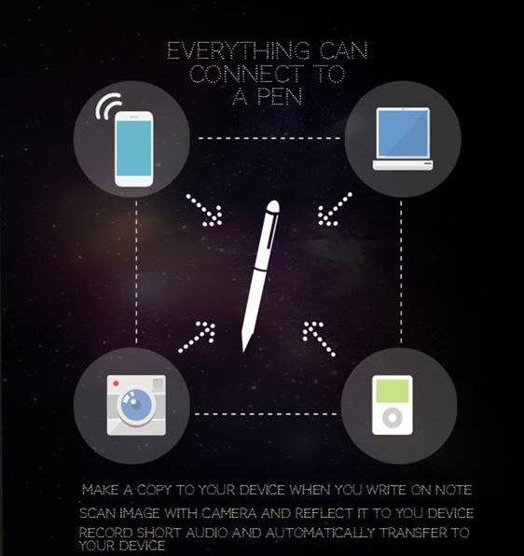



Place strategy
Placing is the value of our product. It is necessary to find out the most efficient and effective distribution channel for Google’s Pen and select the best intermediaries. This section will discuss physical distribution of product, Warehousing, as well as technology, which distributes product through only available outlets.
Google will adopt selective distribution strategy. And use both direct and indirect distribution.

Distribution Channel
The distribution channel has a variety of types available. It is depends on types of product to use different types of channel. These channels are important in the marketing mix because it has each benefit that is including time utility, form utility, place utility and exchange efficiency.

The channels for Google Pen will be the distribution channel 1, 2 and 3.
Channel 1 is direct distribution because producers deals directly with consumer. This is benefit to consumer because they can but product with cheaper price and producers can offer better customisation of the product. For example, buying from website is both direct and indirect distribution.
Channel 2 is indirect distribution that involves retailer between producer and consumers. Most of large retailers are using this channel to deal directly with producer. Most of consumer prefers to buy from retailers rather than deal directly with producer because they can compare different similar products before they make any purchases.
The best channel for Google Pen will be “Producer Wholesaler Retailer Consumer”, which is distribution channel 3 because Google Pen will be placed into numerous retailers that generally trade technological goods. From this channel, Google sells product to wholesaler, then wholesaler sell on to the retailers, and lastly to consumers will purchase products. Producers can take the advantage that instead of dealing with large volumes of individual consumer, dealing with smaller volumes of wholesalers to large number of buyers. Therefore it is less time consuming and efficient. For retailers, instead of dealing with numerous producers, they can buy a range of different products from just one source, which is the wholesaler.

Physical Distribution
Physical distribution involves order processing, inventory management, warehousing and transportation. (Elliott et al, 2012) We will focus on discussing warehousing, transportation and some technology.

Warehousing
Google uses warehouse to store our physical products in order to satisfy our customer’s need and minimise holding cost. Also Google can prepare for a sharp increase in demand for product and avoid shortage. Additionally, having warehouse can reduce price of transportation because it is possible to deliver large quantity to warehouse from producer at one time and instead of make numerous transportation of small amount of products. Thus having warehouse is both efficient effective method of store inventory.

Transportation
One of the main components in physical distribution is transportation. Since Google Pen is planned to sell in Australia and not any other countries, delivery by using road and air will be most suitable method of transportation. However two of them have both advantage and disadvantages each.
Road transport has the most extensive infrastructure and that makes it most flexible transportation method. It is effective when delivering short to middle distant deliveries with fast speed. However it is more expensive than rail and there is higher chance of accident or delays than any other methods of transportation. It is most suitable transportation for Google Pen because Google pen is light weighted and products can be delivered to stores or houses quickly.
Air has very high delivery cost and might be inefficient because it is available between specific locations only. However it is faster than any other transportation method. Therefore if Google needs to transport product as soon as possible because of shortage of inventory, and it is too far away from warehouse, we can use this method to minimise the delivery time.

Technology
It is important to track and check Google’s product. Google will use Radio Frequency Identification (RFID) which is an electronic tag that contains product information. (UTS Online) Using RDIF is necessary to manage stocks effectively and efficiently.

Intermediaries

Retailer
There are numerous types of retailers but generally we can arrange them into five categories. That is general merchandise retail store, speciality retail store, direct marketing, door to door selling and automatic vending. (UTS Online)
Like most of electronic products, Google pen is going to be sold from general merchandise, speciality and online retailing. Such as Dymocks, JB Hi-Fi, Dick smith, Myer, David Johns etc. It will be placed on technological section in the stores. We will ask retailers to secure a good place for our product. Not only in the electronic section, to place Google pen next to the waiting line. So people can see out product and have a look. This will inform our new product and remind them.

Wholesaler

Wholesaling is when products are brought for resale, other use in a business or use as inputs in other product. Wholesaling does not include consumers in their business deal and only make transaction with businesses.
Full-service merchant wholesalers will be involved in Google’s transaction channel of Google Pen. Merchant wholesalers are independently owned and take ownership of product and make transactional connections between producers and retailers. It is more effective and less time-consuming than contacting directly to retailers because full service wholesalers will take ownership of Google pen and control most of marketing factors, such as buying, selling, delivery and storing.

Conclusion
The Google Pen is use as device to record things in perfection, however the much bigger aim is to bring an evolution of our daily life, giving the object ‘pen’ a rebirth and redefining the word ‘record’. As for now, the two different Google Pen will be enough for the current market and the features will fulfil most purpose of consumer’s needs. However one thing for sure is that as time goes by, technology will enhance therefore bring more features to the pen, leading the development and upgrade for the pen to unless possibility.
There are three main competitors that have a significant impact to Google in this area; those competitors include HTC, Samsung, and Huawei. In order to embrace those impacts, a truthful identification of strength and weakness is essential, as this was covered through the SWOT analysis in the report.
The marketing objectives are to make the pen becoming a new trend for the world, ultimately leading to increasing profit for the brand and publicity. The basic price for the Google Pen will be set at $99 dollars. A price which is affordable and does not seems cheap.
The Google Pen will very soon be announced and for sales in retail stores!

Reference list
Australian Bureau of Statistics, ‘Australian Demographic Statistics, Mar 2014’, 2014,
<http://www.abs.gov.au/ausstats/abs@.nsf/mf/3101.0>.
Cambridge dictionaries online 2014, Business English Dictionary, viewed 23
November 2014, < http://dictionary.cambridge.org/dictionary/business-
english/tech-savvy>.
Danzarrella, 2013, ‘What is Viral marketing?’, viewed November 20 2014,
<http://danzarrella.com/what-is-viral-marketing.html>.
Elliott, G., Rundle-Thiele, S., Waller, D., 2012, ‘Marketing’, 2nd edition
Elliott, G., Rundle-Thiele, S., Waller, D., 2014, ‘Marketing’, Chp7- Product.
Flores N., 2014, ‘Online Computer and Tablet Sales in Australia’, IBIS World Industry
Report, viewed 20 November 2014,
<http://clients1.ibisworld.com.au.ezproxy.lib.uts.edu.au/reports/au/industry/
default.aspx?entid=4170>.
Feldman, D., 2002, ‘Modelling Pricing Strategy’, Management and Applications,
viewed 20 November 2014.
Google Inc. Form 10-K 2013, ‘Google Inc.’ viewed 24 November 2014,
<https://investor.google.com/pdf/20131231_google_10K.pdf>.
Google Inc. SWOT Analysis 2014, ‘Google Inc. SWOT Analysis’, pp. 1-10, Business Source
Complete, EBSCOhost, viewed 23 November 2014.
Google 2014, History of our depth, viewed 23 November 2014,
<http://www.google.com/about/company/history/>.
Interest Live Stats 2013, viewed 23 November 2014,
<http://www.internetlivestats.com/google-search-statistics/>.
Jurevicius, O., 2013, ‘SWOT analysis of Google’, viewed 23 November 2014,
<http://www.strategicmanagementinsight.com/swot-analyses/google-swot-analysis.html>.
Market Line 2014, ‘Google Inc.’, viewed 24 November 2014,
<http://advantage.marketline.com.ezproxy.lib.uts.edu.au/Product?pid=5B199F61-
608D-4923-B4A3-F5EE15285ADE&view=Overview>.
McQuerry, L., 2012. The Objectives of Marketing Promotions, viewed 21 November
2014, <http://yourbusiness.azcentral.com/objectives-marketing-promotions-
4328.html>.
‘Push and Pull marketing strategies’ 2014, Marketing made simple, viewed 20
November 2014, < http://www.marketing-made-simple.com/articles/push-pull-
strategy.htm#.VHNBlvmSyS9>.
ProQuest 2013, ‘Google Inc.: Technology & Communications - Company Profile,
SWOT & Financial Report’, viewed 23 November 2014,
<http://search.proquest.com.ezproxy.lib.uts.edu.au/business/docview/
1553174098/A5332857F93240BDPQ/2?accountid=17095#>.
Schermerhorn, J., Davidson, P., Poole D., Simon, A., Woods, P. & Chau, S., 2011,
Management, 4th Asia-Pacific Edition, John Wiley & Sons, New York.

